1. **Page 93, Section 3.9.2, problem 12**

dArray SDWORD 50 DUP(?)

1. **Page 93, Section 3.9.2, problem 13**

bArray BYTE 500 DUP(“TEST”)

1. **Page 93, Section 3.9.2, problem 14**

bArray BYTE 20 DUP(0)

1. **Page 94, Section 3.9.2, problem 15**

21

43

65

87

**(5) Page 137, problem 3 (Summing the Gaps between Array Values)**

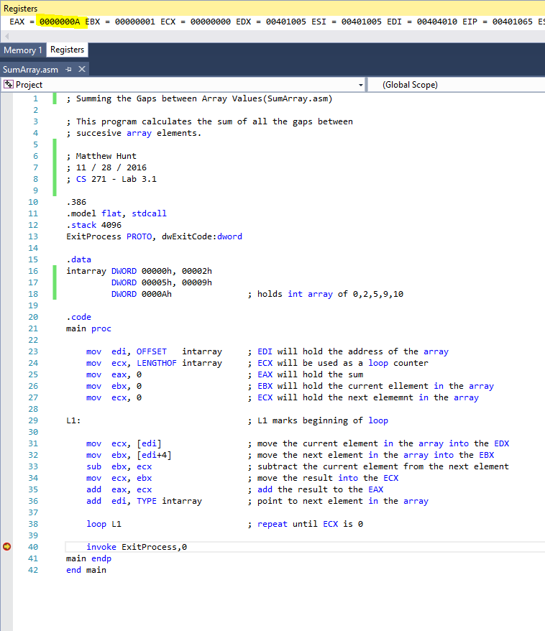

**(6) Page 138, problem 5 (Fibonacci Numbers)**

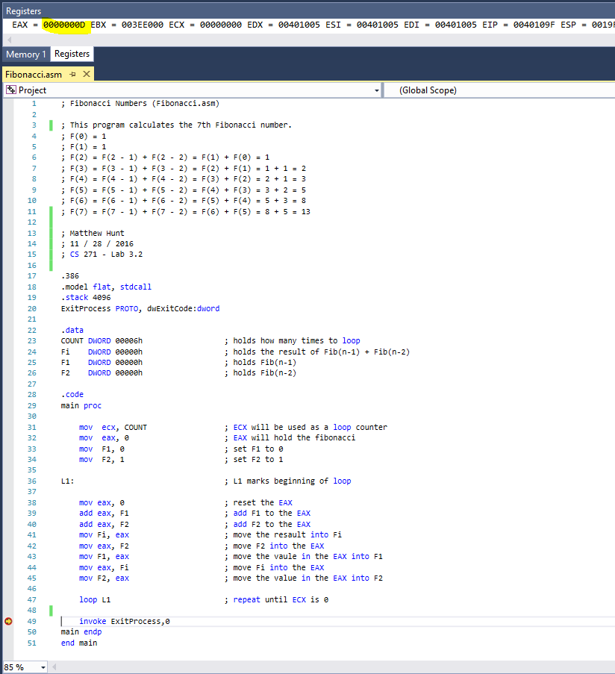

**(7) Page 138, problem 6 (Reverse an Array)**

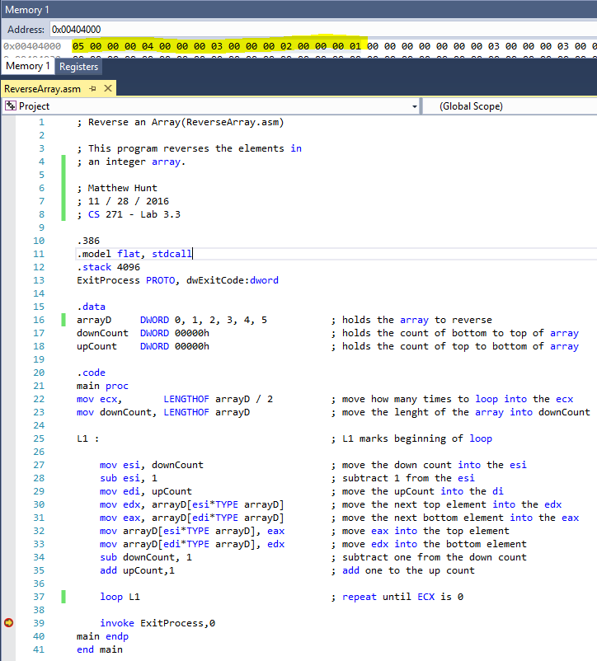

**(8) Page 138, problem 7 (Copy a String in Reverse Order)**

